BEST ENLIST – TASK 1

// Installed Python and Pycharm

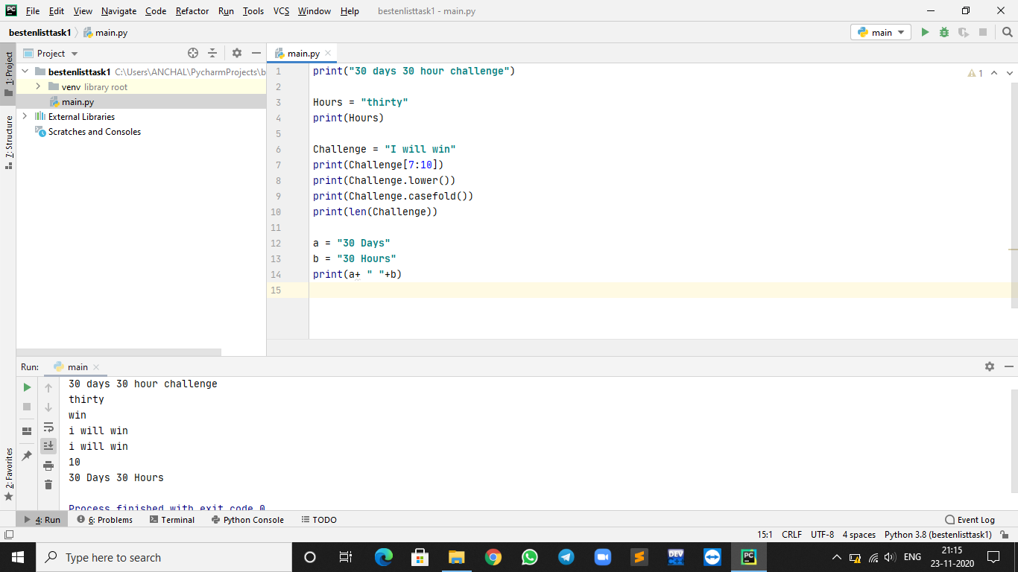

// Task – Sliced String

